CECS 328 Midterm 2 Materials: Build Max Heap, Max Heapify, Heapsort, Priority Queues (Maximum, Extract Max, Insert, Increase key, Insert Key) . QuickSort, Partition, Randomized Quicksort, Analysis of QuickSort, and Binary Search Trees.
UPDATED AS 4/11/20 6 PM
Chapter 6 – HeapSort
Section 6.1 - Heaps
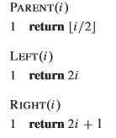
HeapSort: An Array object that you can view as a nearly complete binary tree. Anther algorithm to sort an array.
O(n lg n) runtime (best, average, worst case).
In place
Not Stable!
MaxHeap: A heap that to which the parent of every node (except the root) has its key >= children.
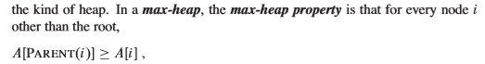

MinHeap: A heap to which the parent of every node (except the root) has its key <= children.
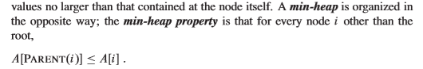
i is the index of the node.
Key is the node’s value.
A leave(s) is a node that contains no children at all.
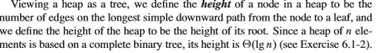
pg. 153
Max – Heapify O(lg n) runtime: Maintaining Max – Heap Property.
Build Max Heap linear O(n) runtime: Producing a max heap from an unordered input array.
HeapSort runs in O(n lg n) runtime: in place, not stable.
Max Heap Insert, Heap Extract Max, Heap Increase Key, and Heap Maximum are all part of MaxPriorityQueue as well as having a O(lg n) runtime.
Min – Heapify O(lg n) runtime: Maintaining Min- Heap Property.
Build Min Heap linear O(n) runtime: Producing a min heap from an unordered input array.
Min Heap Insert, Heap Extract Min, Heap Decrease Key, and Heap Minimum are all part of MinPriorityQueue as well has having a O(lg n) runtime.

Section 6.2 – Maintaining the Heap Property
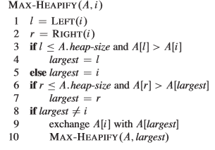
Heap Size: number of nodes including the root.
Max Heapify: An algorithm that converts a heap into a max heap. It ensures that the parents in the binary tree are greater than or equal to its children (left and right).
Min – Heapify (A, i)
l = left(i)
r = right(i)
if l <= A.heap-size and A[l] < A[i]
smallest = l
else smallest = i
if r <= A.heap-size and A[r] < A[smallest]
smallest = r
if smallest != i
exchange A[i] with A[smallest]
minHeapify(A, smallest)
*Note that calling max/min heapify on a node without children (leaves) will have no effect.
Runtime of max heapify on a node of height h is O(h).
Worst case: When the bottom level of the tree is exactly half full. Children’s subtrees each have size of at most (2n/3).
Section 6.3 – Build a Heap
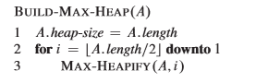
Build Max Heap: To actually build a max heap from an array. It will iteratively call or in a recursive manner will call max heapify algorithm to ultimately create a max heap. The reason why the floor(A.length/ 2) exists because there is no point of running max heapify on nodes without children(leaves) and it automatically disregards the children.

*Note that if a problems asks “Is the array a max heap?”, the best way is to build the heap (heap presepctive) and follow the algorithm until it’s done. Yes, is if you followed the algorithms (build max heap and max heapify) and you did not have make an exchange. If there is at least 1 exchange that you have to make, then you have proved that it is not a max heap (breaks the max heap property!).

Build-Min-Heap(A):
A.heap-size = A.length
for i = floor(A.length/2) downto 1
Min-Heapify(A, i)
Build Min Heap: To actually build a min heap from an array. It will iteratively call or in a recursive manner will call min heapify algorithm to ultimately create a min heap. The reason why the floor(A.length/ 2) exists because there is no point of running min heapify on nodes without children(leaves) and it automatically disregards the children.

*Note that if a problems asks “Is the array a min heap?”, the best way is to build the heap (heap presepctive) and follow the algorithm until it’s done. Yes, is if you followed the algorithms (build min heap and min heapify) and you did not have make an exchange. If there is at least 1 exchange that you have to make, then you have proved that it is not a min heap (breaks the min heap property!).

Section 6.4 – The HeapSort Algorithm
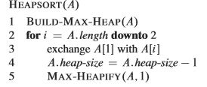
HeapSort: Builds a max heap from an array, then sorts the array based on the heap. Taking the root of the tree (heap) in each iteration and setting that as the last element in the sorted array, then iterates to obtain the second to last element in the sorted array, then iterates to obtain the third to last element in the sorted array, and so on. (Time Consuming!)
*Note that the heap must be a max heap before starting the heap sort algorithm or it will have to build a max heap.
HeapSort Function Runtimes:
HeapSort: O(n lg n) runtime
MaxHeapify: O(lg n) runtime
MinHeapify: O(lg n) runtime
BuildMaxHeap: O(n) runtime
BuildMinHeap: O(n) runtime
Summay of HeapSort: For every iteration of heapsort, we are building the sorted array from the end because we keep taking the root of our heap and placing it at the end of the heap. Removes the largest element from the heap and adding to the end of the sorted array, thus reducing the heap size by 1 every iteration.
< 1st element, 2nd element, ... ,3rd to last element, 2nd to last element, last element>
By the time we reach to the very last element while proceeding with the heapsort algorithm, the 1st element is already the smallest.

Section 6.5 – Priority Queues
Definition:
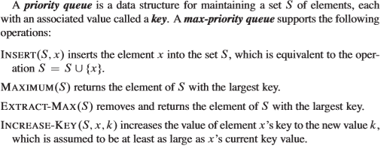
In other words, the max part of a priority queue keeps track of jobs to be performed and their relative priorities.
e.x: Network printers and willing to implement a priority queue where as someone wants to print 500 pages versus someone who is only going to print 1 page.
It’s not quite about neither the sequential order nor which one finishes faster, but rather you want to base it off of some sort of a key value.
Key Value Examples: (1) Is the office of the president doing the printing OR a lower priority office doing the printing? (2) 500 pages going to take a long time versus 1 page that is going to be very quick. There’s a lot of key variables and key values that weigh in.
Operations:
- Maximum(S): returns the elements S with the largest key. (returns the largest key in your array).

- Extract Max(S): removes and returns the element of S with the largest key.

- Increase-Key(S, x, k): S is the set. X is the node that you want to increase. K is the new node’s value.

- Insert (S, X): S is the set. X is the actual key value. Inserts key x, into the set S. S = S U {x}. (Inserting a node with a key into set S).

Difference Between Extract Max and Maximum:
- Maximum just returns the max value and not removing the element from the set.

- Extract Max actually removes the element of the set and returns it

Heap Maximum:
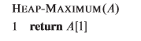
Heap Extract Max:
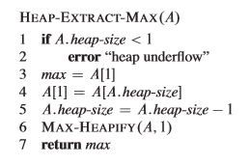
Heap Increase Key:
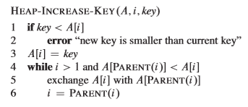
Max Heap Insert:
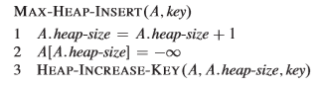
Runtime of Max Heap Insert on n – element heap is O (lg n).
Runtime of Heap Increase Key is O (lg n).
MinPriorityQueues:
Operations:
- Minimum(S): returns the elements S with the smallest key. (returns the smallest key in your array).

- Extract Min(S): removes and returns the element of S with the smallest key.

- Increase-Key(S, x, k): S is the set. X is the node that you want to decrease. K is the new node’s value.

- Insert (S, X): S is the set. X is the actual key value. Inserts key x, into the set S. S = S U {x}. (Inserting a node with a key into set S).

Difference Between Extract Min and Minimum:
- Minimum just returns the min value and not removing the element from the set.

- Extract Min actually removes the element of the set and returns it

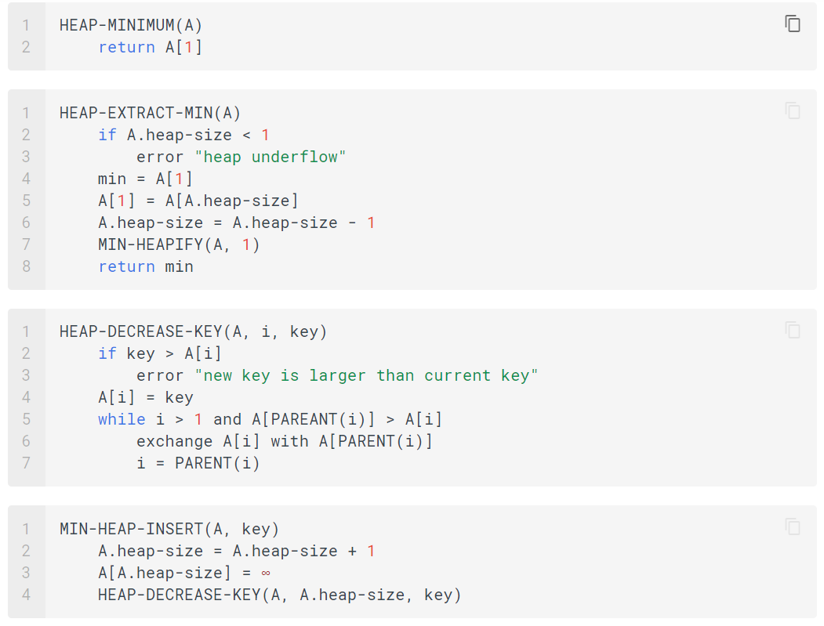

Chapter 7 – QuickSort
Section 7.1 – Description of QuickSort
Properties of QuickSort:
Divide and Conquer Sorting Algorithm
Sorts in place (you have a constant amount of memory that is needed to sort)
Not stable (Auxiliary Data to the keys will not the same order as the input).
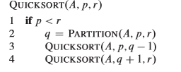* Time Consuming
p represents the index of the first element of the array.
r represents the index of the last element of the array.
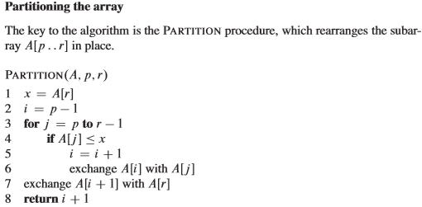
Pivot: Viewed as a key to compare with (array index r).
Goal of QuickSort: To have values less than or equal to the pivot on the left hand side of the pivot and all the values greater than the pivot to be on the right hand side of the pivot (Partition).
Note that the book always selects the last element of the array to be the pivot.
However, as you recurse through the algorithm, the pivot will change.
After you run partition on an array, the pivot will be in its final position (index), the pivot is going to remain where it is (index) and the pivot does not change along with its index.
You must get you q value by finishing partition before recursively calling quicksort.
Running quicksort on lines 3 and 4 of the algorithm will perform QuickSort on the left hand side and right hand side , ultimately, you will get a sorted array. (DO NOT INCLUDE THE PIVOT WHEN RECURSIVE CALLING QUICKSORT!).
The point of calling QuickSort (A, p, q – 1) is to recursively QuickSort elements that are less than or equal to the pivot.
The point of calling QuickSort (A, q + 1, r) is to recursively QuickSort elements that are greater than the pivot.
When recursively calling QuickSort (lines 3 and 4 of the algorithm), if p is not less than r, then there is NO EFFECT at all.
QuickSort Concept: To have elements less than or equal to the pivot to the left of it, and the elements that are greater than the pivot to the right of it. RECURSE until all elements are sorted.
The book will always select the last element of the array to be the pivot; however, there are many different variants such as the pivot being the first element, MEDIAN OF 3, middle element.
Caveat: Even though it may not matter where the pivot is, the thing that matters is the whether the array is sorted or not because it can highly affect runtime.
Section 7.2 – Performance of QuickSort
Worst Case of QuickSort: The pivot was NOT GOOD! Essentially, the worst case scenario happens when your pivot (e.g.: the largest element) and nothing changes (elements SWAP THEMSELVES). In fact, the worst case scenario is if the elements are already sorted. If the elements are already sorted, you get a $θ$(n²) runtime – really bad; however, in the average case, the runtime is $θ$ (n $\log_{2}{n}$).
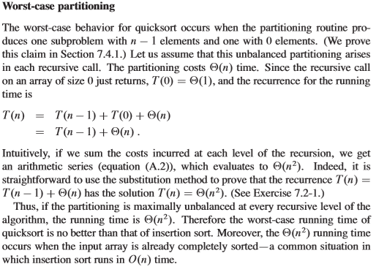
Recap of Worst Case of QuickSort: If your elements are sorted in order, regardless if it is in increasing or decreasing order (worst case scenario) because what happens is every time you choose a pivot, you basically just move 1 element at time or you’re examining one element at a time.
Example of Worst Case: If it is already sorted and let’s say ascending order and you want to sort in ascending order through QuickSort, no elements are going to move, but it is going to have to examine, move the pivot one element at a time in each recursion, that’s why the worst case is $θ$ (n²).
Average case of QuickSort: $θ($n$\log_{2}{n})$.
Advantages of QuickSort: Being a very popular sorting algorithm because its average case runtime is $θ($n$\log_{2}{n})$ and it sorts in place.
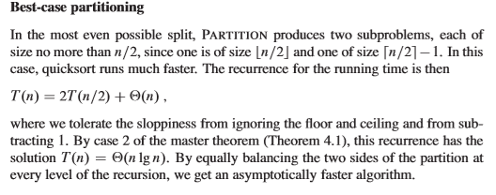
Average Case Partitioning
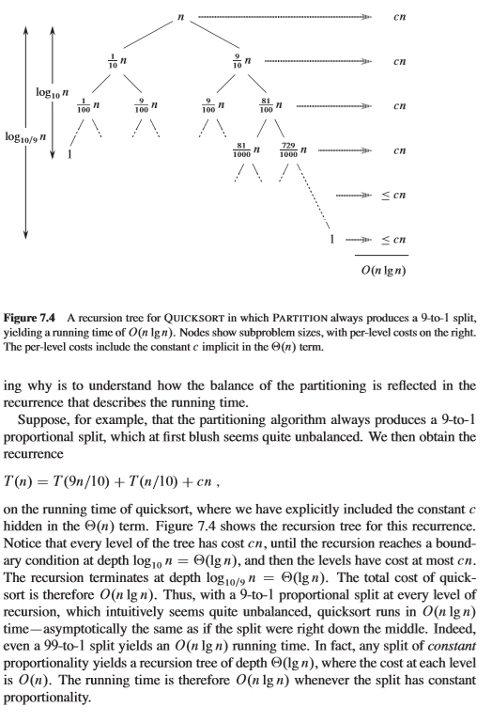

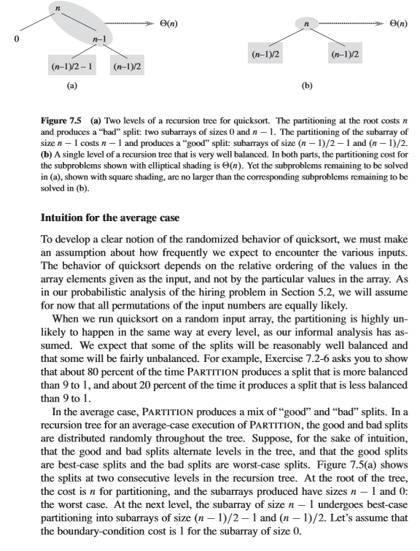

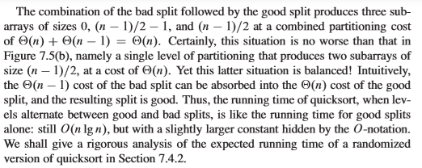

Section 7.3 – Randomized QuickSort
Randomized QuickSort: on page 179. REDUCES the likelihood of choosing a BAD PIVOT. This is done by randomly choosing an element as a pivot.
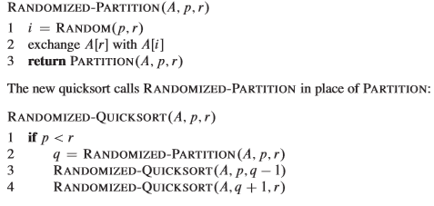
When a BAD PIVOT is chosen and a recurvise QuickSort is called, it recurses but NOTHING HAPPENS!
*Note that in Randomized QuickSort, in the Randomized-Partition, the line i = RANDOM(p, r), what that means is that you can choose any index to be the pivot within the range of p and r. And then it exchanges the last element of the array with the element you randomly chose and then returns Partition(A, p, r).

Keep recursing with randomized quicksort until you have a sorted array.
Section 7.4 – Analysis of QuickSort
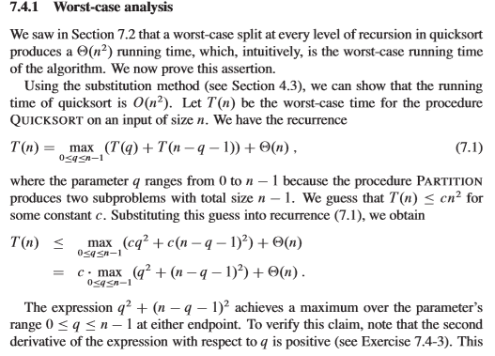

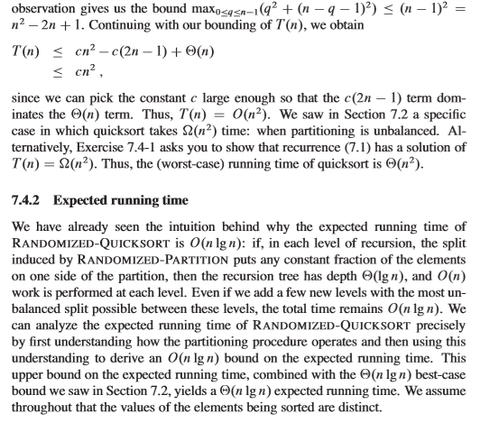
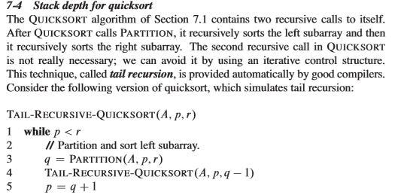
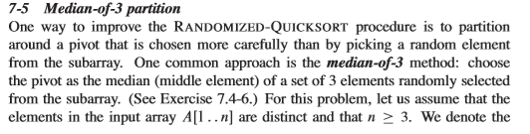
Chapter 12 – Binary Search Trees
Binary Search Tree: A tree where each node will have at most two children hence based on the word binary.
Properties of Binary Search Trees:
Left Hand Side of the Node: You will have keys (values) that are less than or equal to the parent.
Right Hand Side of the Node: You will have keys (values) that are greater than or equal to the parent.
Formal Definition: Let x be a node in a binary search tree.
If y is a node in the left subtree of x, then y.key <=x.key
If y is a node in the right subtree of x, then y.key >= x.key
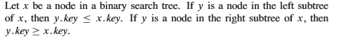
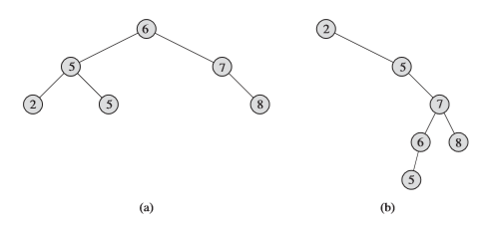

One way to print out the values of a binary search tree is through a InOrder Tree Walk.
In Order Tree Walk:
You are recursively going through the left hand side of the root as well as the right hand side. You will recurse back up
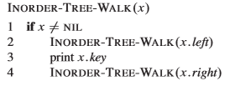* Easier to eyeball. Scarier to write out by hand at first.
* Parameter is the pointer of the root of the tree
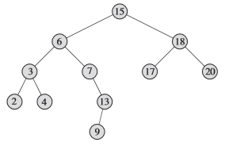Figure 12.2
InOrderTreeWalk of Sample A: 2, 5, 5, 6, 7, 8
InOrderTreeWalk of Sample B: 2, 5, 5, 6, 7, 8
InOrderTreeWalk of Figure 12.2: 2, 3, 4, 6, 7, 9, 13, 15, 17, 18, 20

Tree Search (Searching a Binary Tree):
1st Version of Tree Search (Recursive)
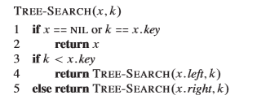
Essentially, when you are searching for a specific element within the binary tree, then you are first checking if x is NIL OR x.key is equal to the value that you are looking for, you return x if it is, then check if the value that you are looking for is less than x.key , then based off of the result of the condition, you either recursively return Tree Search(x.left, k) or Tree Search (x.right, k) until if x is either NIL or x.key is equal to the value that you are searching for.
*Allows you to traverse a binary tree to search for a key.
x is the root of the tree.
k is the key that you are searching for (value).

2nd Version of Tree Search (Non – Recursive)
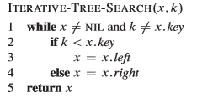Much Easier
Essentially, when you are searching for a specific element within the binary tree, then you are first checking if x is not NIL AND x.key is equal to the value that you are looking for, you return x if it is x is NIL and the value that that you are searching for is equal to x.key, then keep checking if the value that you are looking for is less than x.key , then based off of the result of the condition, you either set x = x.left or x. = x.right until it breaks out of the while. Last, return x (either NIL or the value that you are looking for).
All in all, both versions of tree search are doing the exact same thing. Either way, x will return NIL if the value that you are looking for does not exist!
1st parameter of Tree Search is the root of the subtree (tree)
2nd parameter of Tree Search is the key (value) that you are searching for.

Tree Minimum
*Finding the minimum value of a binary search tree: Traverse the left edge all the way down to the bottom. (DO NOT USE RIGHT EDGE to find minimum value). Only use the LEFT EDGE!
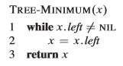
Tree Maximum
*Finding the maximum value of a binary search tree: Traverse the right edge all the way down to the bottom. (DO NOT USE LEFT EDGE to find the maximum value). Only use the RIGHT EDGE!
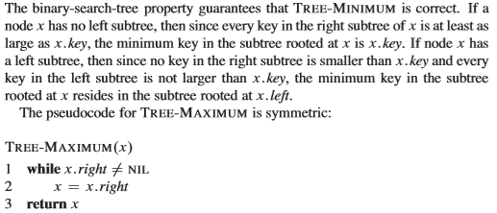
*For tree minimum and tree maximum, keep going down the left or right (while loop) and STOP WHEN x.right == NIL or x.left == NIL, then return x.
*Tree Successor, Insert Node, Delete Node, Pre – Order Traversal, and Post Order – Traversal will be on the final!

